Mi-17 Fact File  On April 1st 2005, Macedonian Air Force and Air Defence Force for the first time officially demonstrated its Mi-17 helicopters. The helicopters are NATO-compatible for night-flying operations.  The process preparing the Air Force for contributing to NATO operations was initiated in December 2003 when the Macedonian Government awarded a (US) $2 million contract for the upgrade of two Mi-17 and two Mi-24V helicopters. The work started in February 2004 and was completed some eight months later. All four aircraft involved have redesigned cockpit layouts, adopted for Night Vision Goggle (NVG) operations, and are also equipped with a Head Up Display (HUD) System. By equipping its aircraft with this equipment, they become one of a very few operators of Night-operation Mi-17 and Mi-24 helicopters worldwide, even before the NATO member countries of Poland, the Czech Republic, Hungary and Bulgaria. | 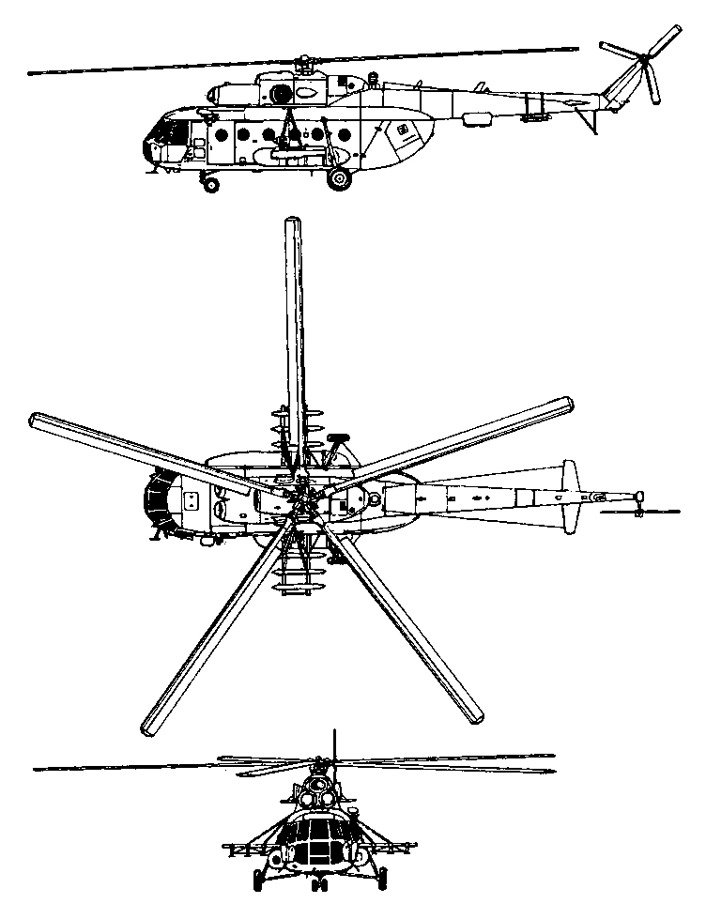
Revealed to the world at the 1981 Paris Air Sshow, the Mi-17 “Hip-H” is known by the Russian military as the Mi-8M “Hip”. It is a revision of the Mi-8 design using a combination of the 'Hip' airframe but with the port-side tail rotor, and fitted with the more powerful engines of the Mi-14. These result in an overall improvement in performance, particularly the hovering ceiling. The type remains in current production for both civil and military use as a cargo-carrying helicopter, with secondary capability as a passenger transport capable of carrying up to 24 passengers, or 12 stretcher cases when used as an ambulance.

General characteristics
Crew: Three – two pilots and one engineer.

Capacity: 32 passengers or 4,000 kg (8,800 lb) on internal/external hard points. The military Mi-17-1V carries up to 30 troops or 20 wounded troops in an ambulance configuration. The civilian Mi-17 is promoted as a cargo-carrying helicopter, with a secondary passenger transport role.

Length: 18.42 m (60 ft 5 in)
Rotor diameter: 21.352 m (69 ft 10 in)
Height: 4.76 m (15 ft 7 in)
Empty weight: 7,100 kg (15,700 lb)
Loaded weight: 11,100 kg (24,470 lb)
Max takeoff weight: 13,000 kg (28,700 lb)

Powerplant: 2× Klimov TV3-117VM turbo shafts, 1,450 kW (2225 shp) each; should one engine stop, output of the other increases automatically to contingency rating of 1,637kW (2,195 shp), enabling flight to continue.

Maximum speed: 250 km/h (156 mph)
Range: 950 km (594 miles)
Service ceiling 6,000 m (19,690 ft)
Rate of climb: 8 m/s (ft/min)
Fuel consumption: 600 kg/h (1,320 lb/h)

